# 

# Henna/Mehndi Library Program

## Parent Permission Slip

Dear Parents & Teens:

The henna program to be presented at the Warner Library uses a substance known as Henna paste. This is a natural substance made from plants that is applied to the skin to make a decorative design. Henna has been used in such a manner for thousands of years. The purpose of this program is to present information about Henna, it’s history and to demonstrate its decorative use on the skin.

Henna is a shrub-like plant known scientifically as Lawsonia Intermis. To create a paste to work with the leaves are picked, dried and crushed into a powder. The powder is mixed with lemon juice, cajuput oil, and lemon grass oil. The paste is piped or painted onto the skin in the design chosen. The paste dries on the skin over the next hour (45-60 min), the longer you leave it on the skin the darker the stain. As the paste dries, it dyes the outer layer of skin, the epidermis, a golden orange. Exposing the design to soap and water during the next 12 hours can stop the natural maturing process. During the next 12 to 36 hours, the color changes to a brown that can range from a gentle coffee color to a deep mahogany.

The design often lasts from 1 to 4 weeks, depending on how fast your body sheds the outer layer of skin. We have found that the average wear ranges from between 10 to 14 days. When the layer has fully shed, there is no residual color or markings. If the design is kept moisturized with a natural oil such as olive oil or coconut oil it will prolong the life of the stain.

Occasionally, Henna decorations have lasted on the skin longer than 3 weeks. Sometimes Henna can irritate people who have sensitive skin. If you have sensitive skin or reactions to natural products from plants or citrus, you should not receive a henna in this program. Those people who do not want to have possibly long-lasting decorations on their skin may also choose not to actively participate in this program. You will still learn about henna and work on some simple designs but you will not receive it on your skin during this class.

For more information on henna the following website has tons of great information: <http://www.hennapage.com>.

By approving the appropriate blanks below, you hereby absolve the Warner Library/Making Faces Parties, its employees, and all program demonstrators of all responsibility for any accidental staining of property, allergic reactions, or other problems in relation to the application of Henna products to the skin.

Parents and children also give permission for Henna to be applied to the skin of the minor child listed below and have discussed I have discussed with my child appropriate symbols and placement on the body of the temporary design.

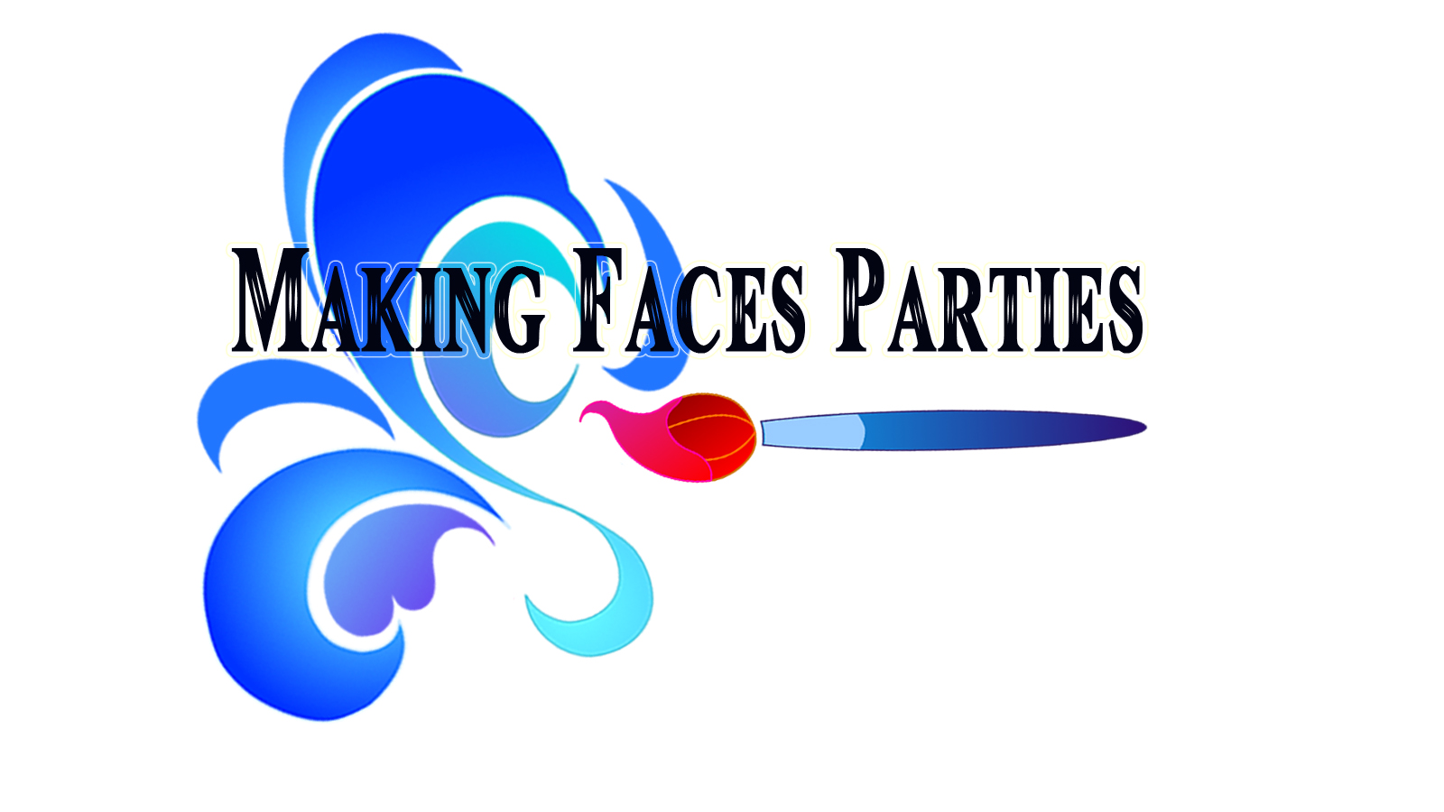

___________________________________________ __________________________________________ Minor Child Adult Guardian

__________________________________________ ____________________________

Please Print Name/ Age Date

Program presented by: Making Faces Parties [www.makingfacesparties.com](http://www.makingfacesparties.com) 914-714-8069