**COMMUNITY BAKE-OFF**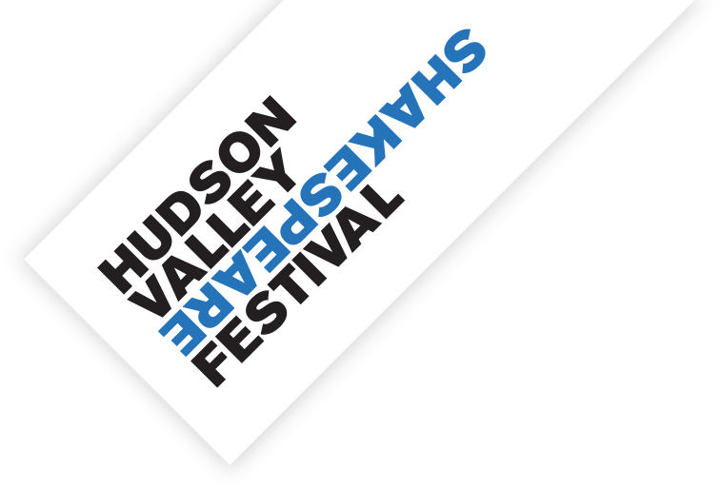

**Frequently Asked Questions**

**What is a Bake-Off?**

Created by the Pulitzer Prize-winning playwright Paula Vogel, the Bake-Off is a communal writing event in which writers are given a random list of “ingredients” to incorporate into a play (for example: a kitchen sink, a front porch, and a withheld secret) to help inspire creativity and give writers permission to play. Hudson Valley community members are invited to submit short plays to be considered as part of the *HVSF Community Bake-Off*. Between 5-7 of these plays will be selected to be performed by professional actors at Hudson Valley Shakespeare on **November 16 & 17**

**What should I expect from the free workshop?**

The basic structure of each workshop is the same: we start out writing monologues and build to writing dialogue and then full scenes. Then we go around the room and tell everyone to say the first thing that comes to mind when they think of the theme. We create a big document of all the ideas from each of the workshops and send it off to our guest playwright, who selects the ingredients from that list and usually adds a few of her own.

**Who is eligible to participate?**

Anyone who has attended any of the bake-off workshops is eligible to submit a play.

**When are submissions due?**

Play submissions will be due on or about Tuesday, October 15th

**When will I find out if my play has been selected to be part of HVSF2?**

We’ll notify you by Friday, October 25.

**When will I need to be available if my play is selected?**

The performance will be held at Hudson Valley Shakespeare on November 16 & 17. You will also be invited to a rehearsal prior to the performances to give feedback to the actors and director.

**How will I know what the ingredients are?**

Our recipe for this year will be crafted by Pulitzer Prize winning playwright Sarah Ruhl, and will be announced on Tuesday, **October 2**. You should include **at least three** of these ingredients in your play.

**How long does my play have to be?**

You should aim for around 10 pages, but if your play is a bit longer or shorter, that is okay.